Highly Available and Scalable Web Application
■ Business Requirement
Design a web application capable of:
• Handling traffic across multiple Availability Zones
• Eliminating single points of failure
• Automatically replacing failed instances
• Scaling infrastructure as demand increases
• Maintaining high availability during infrastructure failures

■ Executive Summary:
This project demonstrates the design and implementation of a highly available and fault-tolerant web application on AWS. The solution leverages Amazon EC2 Auto Scaling Groups, Application Load Balancers (ALBs), Launch Templates, Target Groups, and Multi-AZ deployments to provide scalability, resilience, and automated recovery from infrastructure failures.
The architecture was validated by:
• Distributing traffic across multiple Availability Zones
• Performing health checks through an Application Load Balancer
• Automatically replacing failed EC2 instances through Auto Scaling
• Demonstrating self-healing infrastructure capabilities
Important cost note: ALB and EC2 can create charges

■ Infrastructure Components:
EC2, Auto Scaling Group, Application Load Balancer, Target Groups, Launch Templates, Security Groups, VPC, Multi-AZ Deployment

■ Architecture Overview:
Users → Route 53/Domain optional → Application Load Balancer → EC2 Auto Scaling Group → EC2 instances across 2 AZs

■ Architecture Diagram:
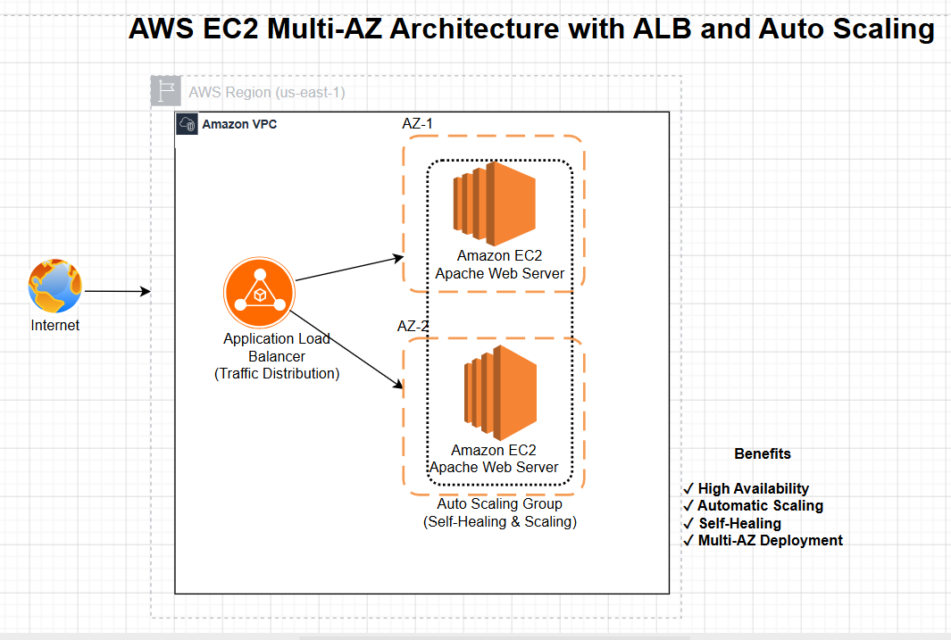

■ High-Level Implementation Steps:
Networking
Use default VPC. Select 2 public subnets in different Availability Zones.
EC2 Launch Template
Goto EC2 → Launch Templates → Create Launch Template
Create a Launch Template containing the EC2 instance configuration, security groups, and bootstrap user-data script(so all the upcoming EC2 instances will have an Apache web server by default).
User data:
#!/bin/bash
yum update -y
yum install -y httpd
systemctl start httpd
systemctl enable httpd
TOKEN=$(curl -X PUT "http://169.254.169.254/latest/api/token" \
-H "X-aws-ec2-metadata-token-ttl-seconds: 21600")
AZ=$(curl -H "X-aws-ec2-metadata-token: $TOKEN" \
http://169.254.169.254/latest/meta-data/placement/availability-zone)
INSTANCE_ID=$(curl -H "X-aws-ec2-metadata-token: $TOKEN" \
http://169.254.169.254/latest/meta-data/instance-id)
cat <<EOF > /var/www/html/index.html
<h1>Hello from Dipti's Scalable AWS Project</h1>
<p>Instance ID: $INSTANCE_ID</p>
<p>Availability Zone: $AZ</p>
<p>Served through Application Load Balancer</p>
EOF
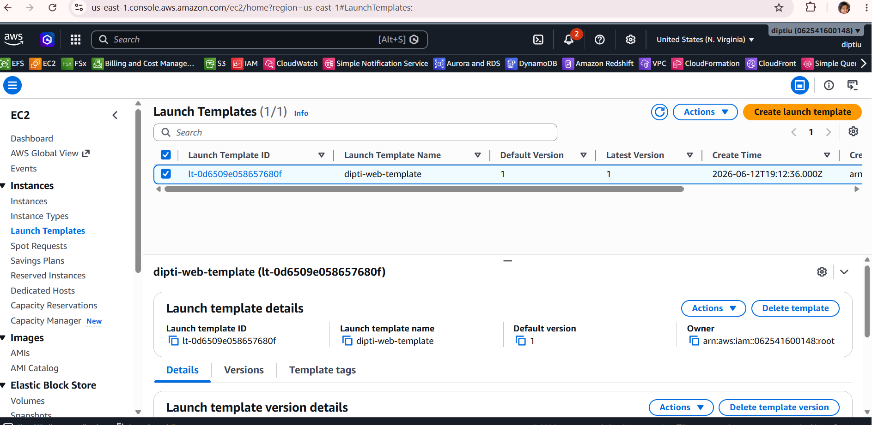
Figure 1: Launch Template Configuration

Quick Summary of steps that we will implement in following Order:
Target Group → ALB → Auto Scaling Group
1. Create a target group: Because ALB needs a target group to forward traffic.
2. Create ALB: Attach the ALB listener to that target group.
3. Create Auto Scaling Group: ASG will use your Launch Template and attach new EC2 instances to the Target Group automatically.
Target Group
Goto EC2 → Target Groups → Create target group
Name: dipti-web-tg
Target type: Instances
Protocol: HTTP Port: 80 VPC: default VPC Health check path: /
Do not manually register your current test instance if AWS asks. We want the ASG to register instances later.
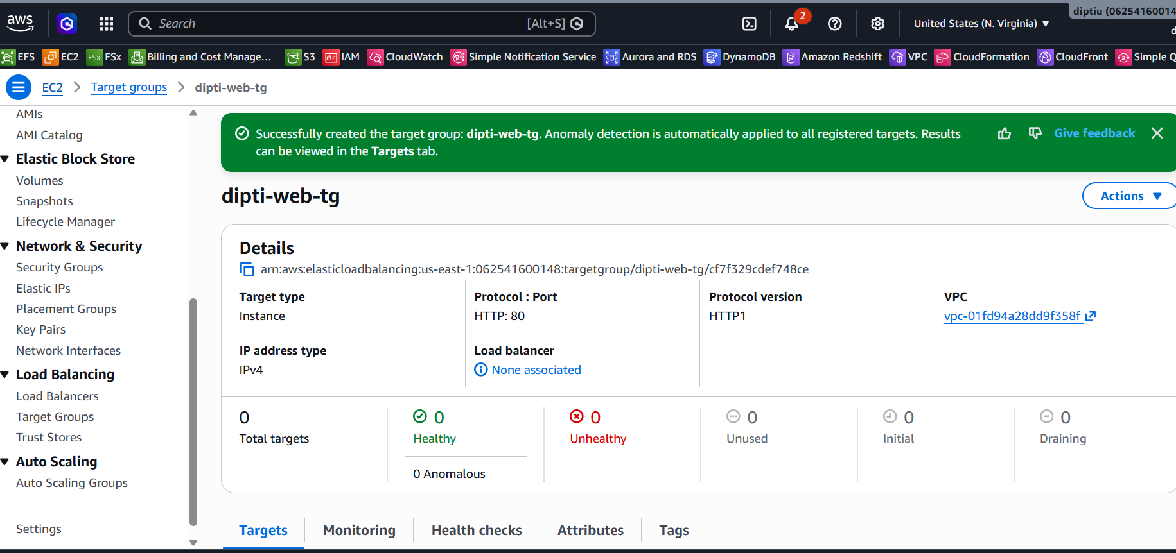
Figure 2: Target Group Creation
Application Load Balancer
Goto EC2 → Load Balancers → Create Load Balancer
Create an internet-facing ALB.
Step 1: Settings:
Name: dipti-web-alb
Scheme: Internet-facing
IP address type: IPv4
Step 2: Network Mapping
VPC: default VPC
Select BOTH subnets: us-east-1a, us-east-1b //This is where our Multi-AZ setup begins. 🚀
Step 3: Security Group
Create a new SG : Name: dipti-alb-sg
Inbound: HTTP 80 from 0.0.0.0/0 Outbound: All Traffic
Step 4: Listener and Routing
Listener: HTTP 80
Forward to: dipti-web-tg (the target group you just created)
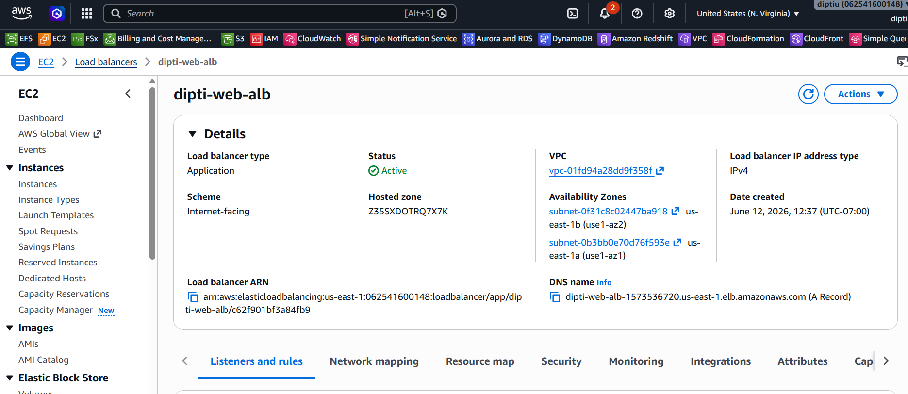
Figure 3: Application Load Balancer Configuration

Once done, go to: EC2 → Load Balancers -> Copy the DNS name.
http://dipti-web-alb-123456.us-east-1.elb.amazonaws.com
At this point, if you open the ALB DNS, it will probably show:
503 Service Temporarily Unavailable or No healthy targets
That's normal because we still have no targets registered.
Auto Scaling Group:
EC2 → Auto Scaling Groups → Create Auto Scaling Group
Name:dipti-web-asg
Step 1 - Select: Launch Template
Choose: dipti-web-template
Step 2 – Network
Select: Default VPC
Subnets: ✅ us-east-1a ✅ us-east-1b
Step 3 - Load Balancing
Choose: Attach to an existing load balancer -> dipti-web-tg //This is the most important step.
When ASG launches instances, they will automatically register in the Target Group.
Step 4 - Health Checks
Enable: EC2 ALB //Both should be checked.
Step 5 - Group Size
Use: Desired Capacity = 2, Minimum Capacity = 2, Maximum Capacity = 4
Step 6 - Scaling Policy : Choose: No scaling policy for now.
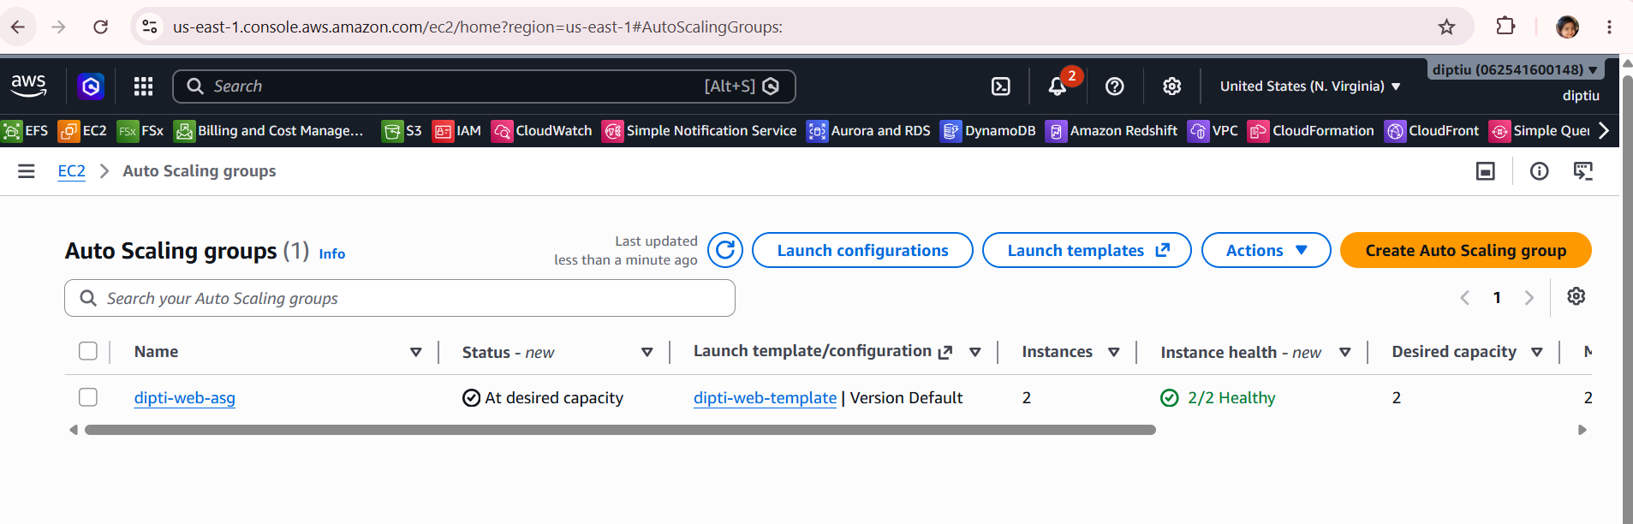
Figure 4: Auto Scaling Group Deployment

As soon as the Auto Scaling group is created, 2 EC2 instances will be launched to meet the min capacity defined in the Auto Scaling group.
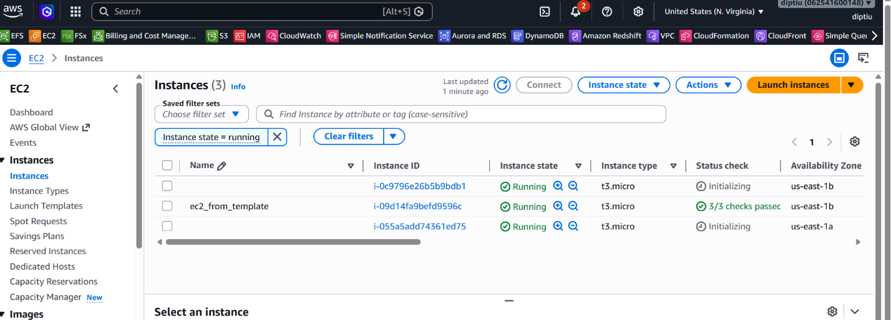
Figure 5: Instance created

■ Validation & Testing:
■ Auto Scaling Demo
- Copy & Open the ALB DNS name: http://dipti-web-alb-1573536720.us-east-1.elb.amazonaws.com
- Refresh the page several times. You should see:
Instance ID: i-xxxx Availability Zone: us-east-1a
Refresh, Instance ID: i-yyyy Availability Zone: us-east-1b
Refresh again: Instance ID: i-xxxx Availability Zone: us-east-1a
It means:
✅ ALB is distributing traffic
✅ Target Group is healthy
✅ Multi-AZ architecture works

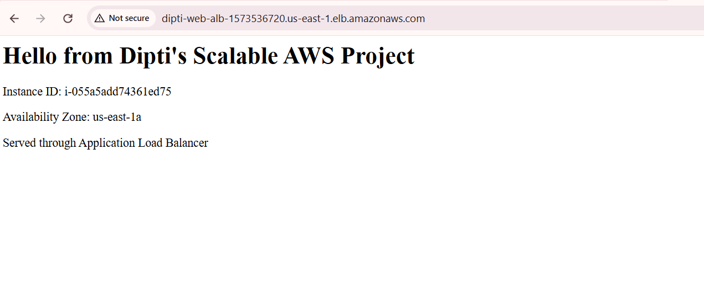
Figure 6.1: Load Balancing Across Multiple Availability Zones

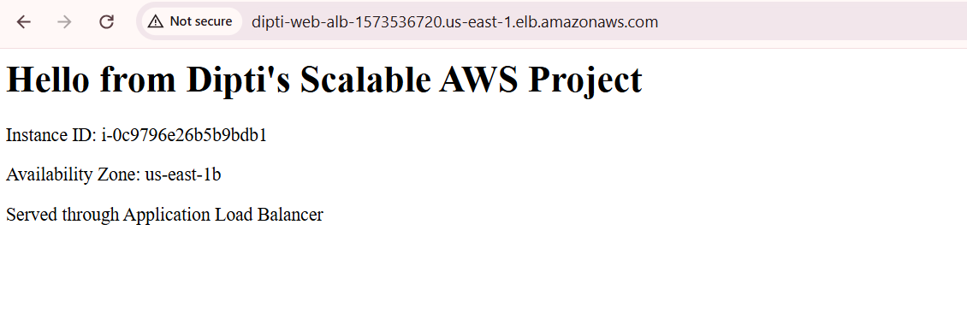
Figure 6.2: Load Balancing Across Multiple Availability Zones

■ Fault Tolerance Demonstration:
1. Go to EC2 Instances. You should see the two ASG-managed instances: i-11111 and i-22222
2. Terminate ONE of them. Not stop. Terminate.
3. Watch: Auto Scaling Group for 2-3 minutes.
What should happen now? Desired Capacity = 2
AWS notices: Only 1 instance exists, and a new instance is automatically launched with a brand-new instance ID.
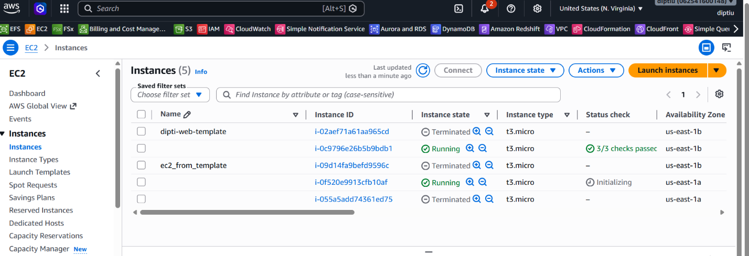
Figure 7: Self-Healing Demonstration Through Auto Scaling
That is the exact demonstration of self-healing architecture.

■ Conclusion:
Designed and deployed a highly available web application using Amazon EC2, Application Load Balancer, Auto Scaling Groups, and Multi-AZ deployment.
- Implemented automated instance provisioning using EC2 Launch Templates and User Data bootstrap scripts.
- Configured Target Groups and health checks to distribute traffic across multiple Availability Zones.
- Demonstrated self-healing architecture by automatically replacing failed EC2 instances through Auto Scaling.
- Applied AWS networking and security best practices using Security Groups and VPC networking.

■ Key Concepts Demonstrated:
✅ High Availability
✅ Fault Tolerance
✅ Elasticity
✅ Load Balancing
✅ Automated Provisioning
✅ Multi-AZ Design
✅ Self-Healing Infrastructure

■ Challenges and Troubleshooting
Issue: Apache installation failed during instance bootstrap.
Root Cause: The EC2 Security Group outbound rules allowed only HTTP (port 80) traffic.
Resolution: Modified outbound rules to allow all traffic, enabling access to Amazon Linux package repositories and the successful execution of User Data scripts.

■ Don’t forget to Cleanup – To avoid charges, follow this Order (Important):
Delete Auto Scaling Group Set Desired = 0
Delete ASG, Load Balancer, Target Group, Launch Template
Verify no EC2 instances remain running

