Container Orchestration of a Full-Stack Application
Using Amazon EKS

Project Overview:
Designed and implemented a containerized full-stack web application that provides information about selected AWS services. The application was developed using Spring Boot for the backend and React for the frontend, containerized using Docker, stored in Amazon ECR, and orchestrated using Kubernetes on Amazon EKS worker nodes.

- Technology Stack Table:
Layer | Technology
Frontend | React + Vite
Backend | Spring Boot
Containerization | Docker
Orchestration | Kubernetes
Image Repository | Amazon ECR
Compute | Amazon EC2
OS | Amazon Linux 2023
Scaling | Auto Scaling
Traffic Routing | Application Load  Balancer

- Architectural Diagram
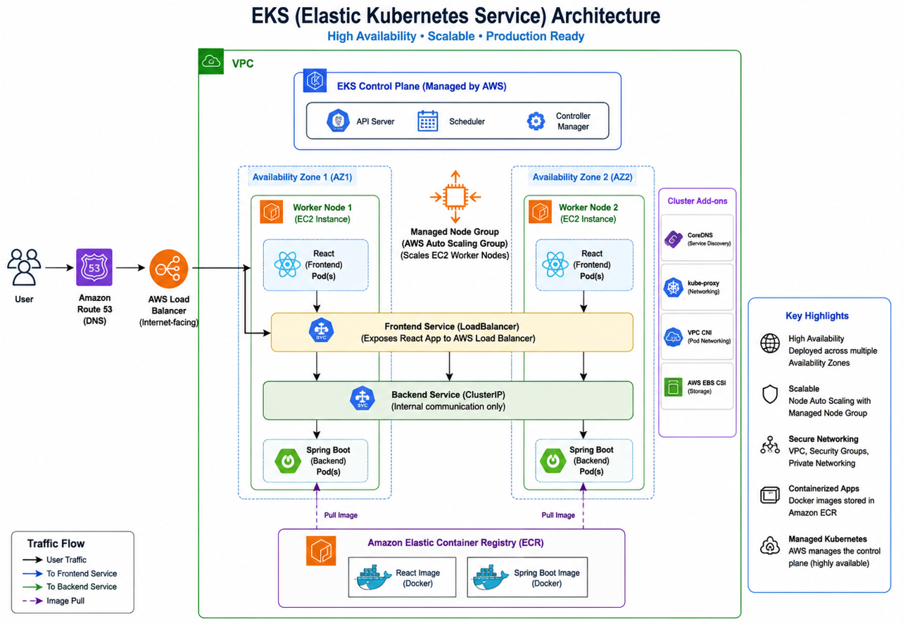
- Code
Source code is available at: https://github.com/uppaldipti/aws-service-info-app.git
- Application running locally:
  - Frontend requests information about the services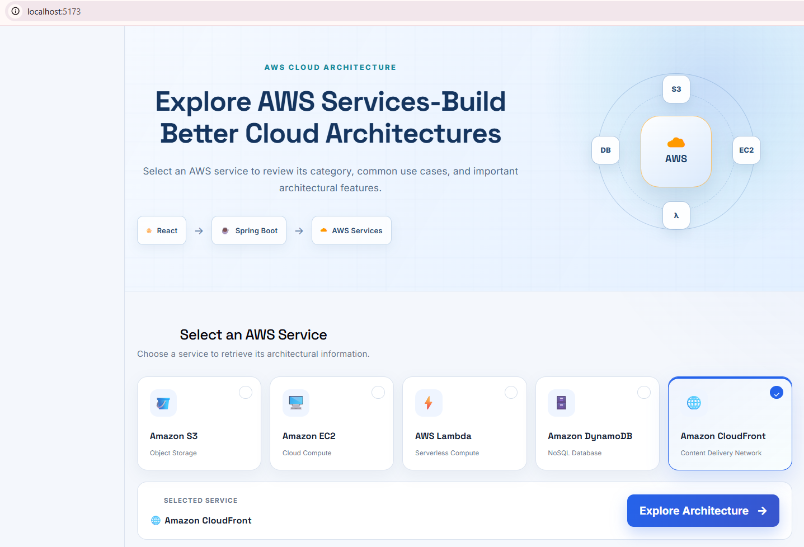
Figure 1: Frontend request.

  - Backend responds
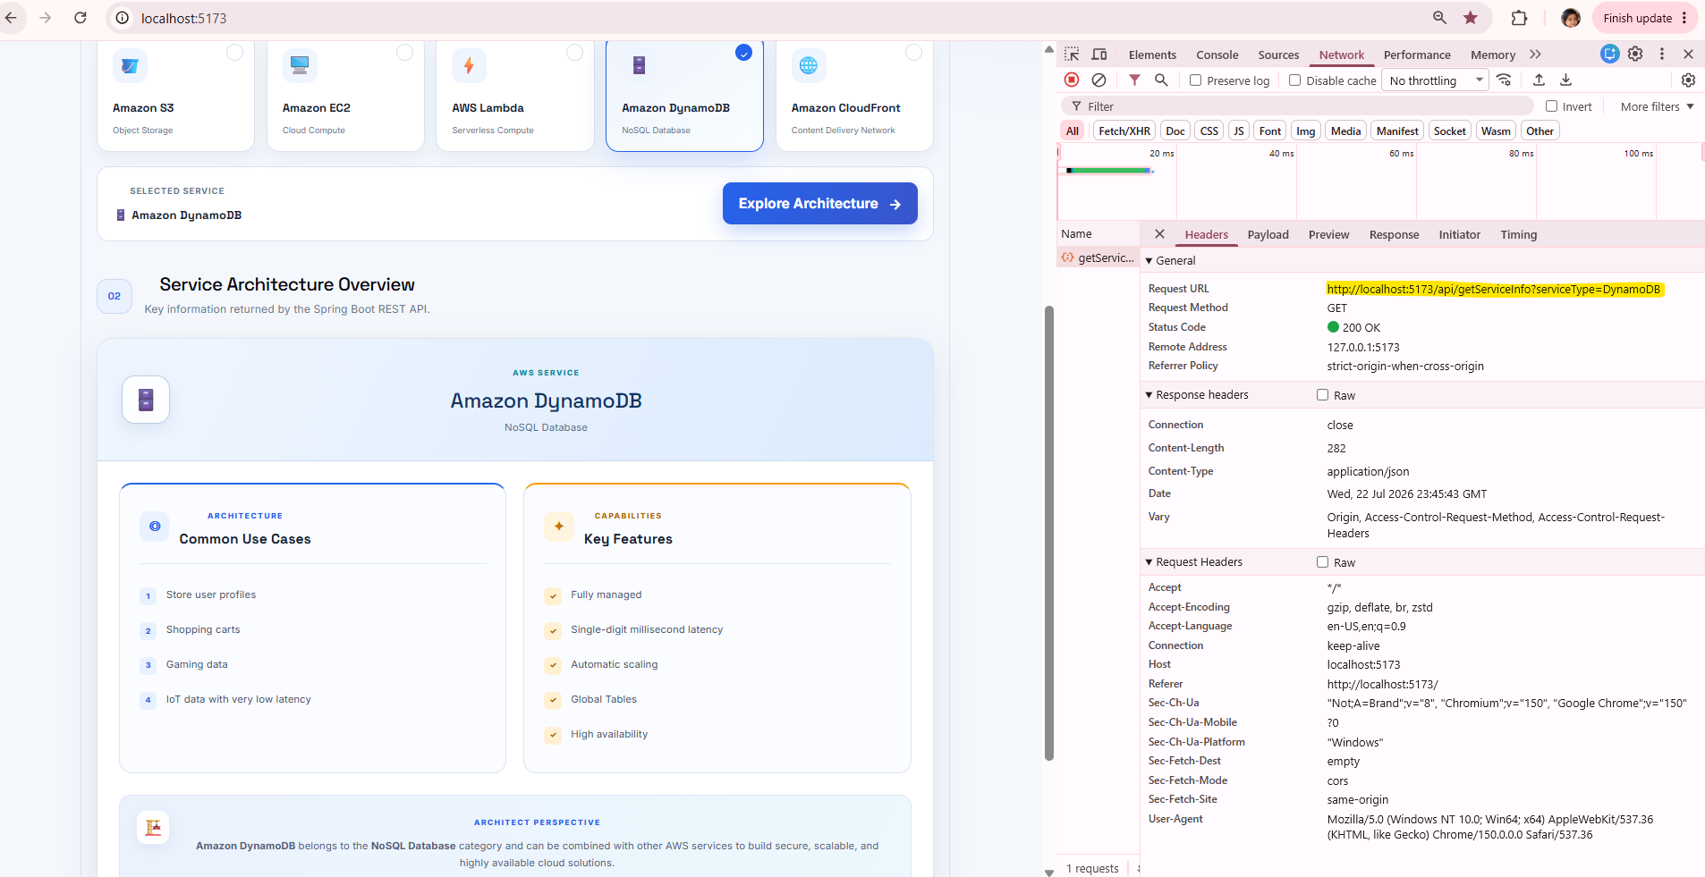
Figure 2: Backend response.

- End-to-End Architecture Flow on Local:
Figure 2 demonstrates the successful communication between the React frontend and the Spring Boot REST API. The browser Network tab confirms that the selected application type is passed to the backend endpoint, and a JSON response is returned successfully.
- Containerization using Docker:
6.1 Why Docker? Docker is used to package an application and its dependencies into a portable container that can run consistently across different environments.
  - Dockerfile Overview: This file is added to the project with the instructions that are required by Docker to build the Docker Image. This Image can be used to run 1 or more containers.

  - Installation: Use powershell or command prompt
Install Docker Desktop
Verify Docker Installation
Install WSL (Windows Subsystem for Linux)
docker --version
docker ps

  - Flow / Code / Build / Run:
- Dockerize React  React Code  ↓  Dockerfile  ↓  Docker Image  ↓  Docker Container  //Code in Dockerfile  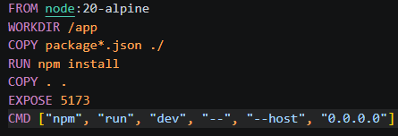  //Build Docker Image  docker build -t aws-service-frontend .  //Run Docker Image  docker run -d -p 3000:3000 --name frontend aws-service-frontend | - Dockerize Spring Boot  Spring boot Code  ↓  Dockerfile  ↓  Docker Image  ↓  Docker Container  //Code in Dockerfile  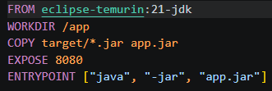  //Create the .jar file  .\mvnw.cmd clean package -DskipTests  //Build Docker Image  docker build -t aws-service-backend .  //Run Docker Image  docker run -p 8080:8080 aws-service-backend
  - After updating both the applications and running the commands, we can now see that the applications are running in their own containers.
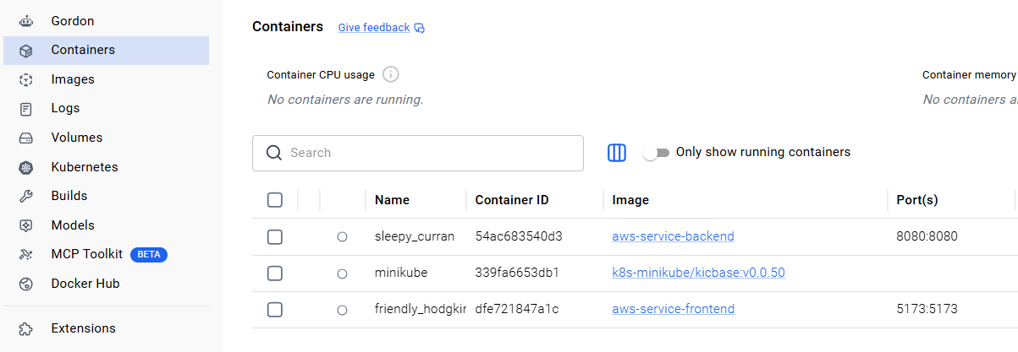
Figure 3: React and Spring containers.
  - In real-world applications, multiple services often need to run together. Managing each container separately can become difficult as the application grows. Docker Compose helps define and manage multiple containers as a single application stack using a single docker-compose.yml file, making deployment and maintenance much easier.
  - Once this is done, we can copy these images to ECR.

- Amazon Elastic Container Registry (ECR):
7.1 Login to your AWS account. ECR – Create Repository.
Settings:
Repository Name: aws-architecture-recommendation-engine
Visibility: Private
Tag Immutability: Disabled (default)
Encryption: AES-256 (default)
Click Create Repository.

7.2 Install AWS CLI & Configure the AWS credentials using command prompt or powershell.

7.3 In the same window - Login to ECR from your local machine using:
aws ecr get-login-password --region us-east-1 docker login --username AWS
--password-stdin <ACCOUNT_ID>.dkr.ecr.us-east-1.amazonaws.com
OR
$ECR_PASSWORD = aws ecr get-login-password --region us-east-1
docker login --username AWS --password $ECR_PASSWORD <ACCOUNT_ID>.dkr.ecr.us-east-1.amazonaws.com

7.4 Tag Images: Docker image tags uniquely identify image versions and destinations. Before pushing to ECR, we tag the local image with the ECR registry URL, repository name, and version tag so Docker knows where to store the image. Tags also help manage multiple versions such as development, testing, and production releases. We are essentially giving Docker the full address of where the image should live in ECR.
React:
docker tag aws-service-frontend:latest <ACCOUNT_ID>.dkr.ecr.us-east-1.amazonaws.com/aws-service-frontend
Spring Boot:
docker tag aws-service-backend:latest <ACCOUNT_ID>.dkr.ecr.us-east-1.amazonaws.com/aws-service-backend
7.5 Push Images: Pushing the image to the mentioned path
React
docker push <ACCOUNT_ID>.dkr.ecr.us-east-1.amazonaws.com/aws-service-frontend
Springboot
docker push <ACCOUNT_ID>.dkr.ecr.us-east-1.amazonaws.com/aws-service-backend
7.6 Verify the Images are stored in ECR Repository as shown.
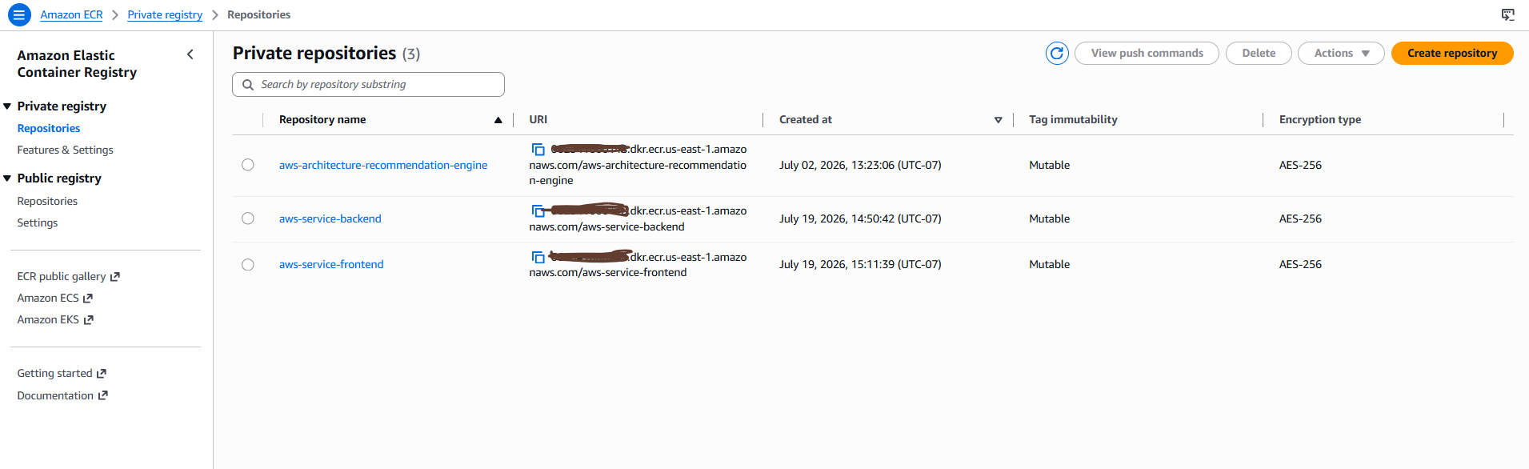
Figure 4: ECR Repository

- Understanding Kubernetes & Amazon EKS?
Kubernetes is a container orchestration platform that automates the deployment, scaling, networking, and management of containerized applications.
In a real-world application, user traffic can increase significantly. To handle this load, the application may need to run multiple instances of its frontend and backend containers across multiple nodes (typically EC2 instances in AWS). Kubernetes schedules these containers into Pods, distributes traffic, restarts failed containers, and ensures the desired number of application instances are always running.
Managing all of this manually would be difficult and error-prone. Kubernetes automates these operational tasks and supports both horizontal scaling (adding more Pods) and vertical scaling (increasing CPU and memory resources).
Amazon EKS (Elastic Kubernetes Service) is AWS's managed Kubernetes service. Instead of installing, upgrading, securing, and maintaining the Kubernetes control plane yourself, AWS manages it for you, allowing you to focus on deploying and running your applications.

8.1 Flow Diagram
Kubectl
│
▼
API Server
│
┌────────────┼────────────┐
▼ ▼ ▼
Scheduler Controller etcd Database
│
▼
Worker Node
│
kubelet
│
Pod
│
Docker Container
Figure 5: K8s flow Diagram

8.2 Understanding Node & Pods:
A Node is the machine that provides compute resources to run workloads. A Pod is the smallest deployable unit in Kubernetes. A Node can host multiple Pods, and each Pod typically contains one container, although it can contain multiple tightly coupled containers that share networking and storage.
Node = Apartment Building
Pod = Apartment (A Pod can have one or more containers.)
Container = Person living in the apartment

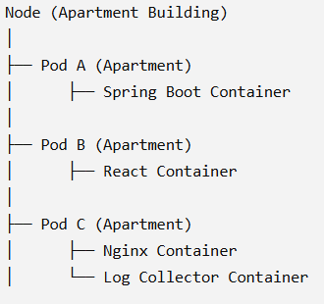
Figure 6: K8s Analogy

If any of the node crashes, the following sequence of events takes place:
The sequence is:
- Controller Manager notices Pods are missing.
- Scheduler looks for another healthy node.
- If Node 2 has enough CPU and memory, the Pods are started there.
- If there isn't enough capacity, the Cluster Autoscaler (or another node provisioning mechanism) can request a new EC2 instance.
- Once the new node joins the cluster, the Scheduler places Pods on it.
So the Controller Manager doesn't directly create nodes—it ensures the desired number of Pods exist.

8.3 AWS-to-Kubernetes terminology table
AWS/Container concept | Kubernetes concept
EC2 instance | Worker node
Docker image in ECR | Container image
Running application container | Container running inside a Pod
Pod | Smallest Kubernetes deployable unit
Managed node group | Group of EC2 worker nodes
EKS cluster | Managed Kubernetes control plane plus connected compute

8.4 Control flow of K8s:
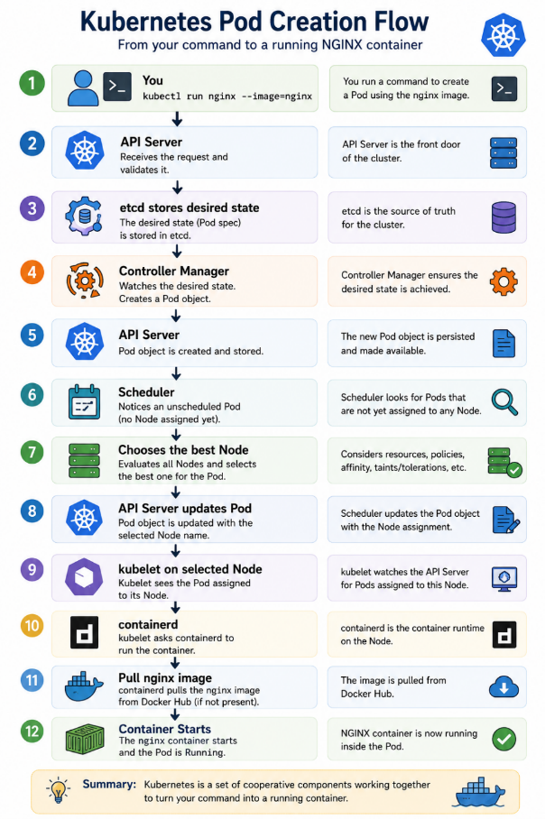
Figure 7: K8s Pod creation

8.5 Install and verify Kubernetes tools:
AWS CLI
kubectl
eksctl
Docker Desktop

Commands:
aws --version
kubectl version --client
eksctl –version //winget install -e --id eksctl.eksctl
docker –version

//get the name of the docker image
Docker images

8.6 Making application Kubernetes compatible:
In the src code, we can see at the root of the project structure
8.6.1 Folder: Kubernetes
8.6.2 Underneath, 4 files:
frontend-deployment.yaml & frontend-service.yaml
backend-deployment.yaml & backend-service.yaml
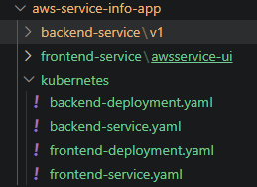
Figure 8: K8s folder
Deployment (deployment.yaml)
- Defines the desired state of the application.
- Specifies the Docker image to run, number of Pod replicas, container port, environment variables, resource limits, and Pod labels.
- Ensures the required number of Pods are always running and manages rolling updates.
Service (service.yaml)
- Provides a stable network endpoint for a set of Pods.
- Uses label selectors to identify the Pods created by the Deployment.
- Routes the traffic to those Pods.
- Specifies how the application is exposed, such as ClusterIP, NodePort, or LoadBalancer.

- Creating EKS Cluster (Manager of a Restaurant)
9.1 Create cluster (Name- aws-service-eks-cluster) - Select all the default values, including VPC, Subnets & the default Core EKS add-ons.
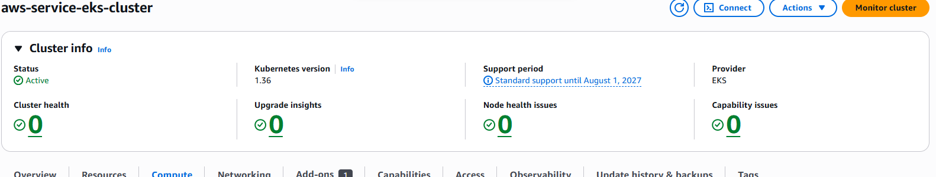.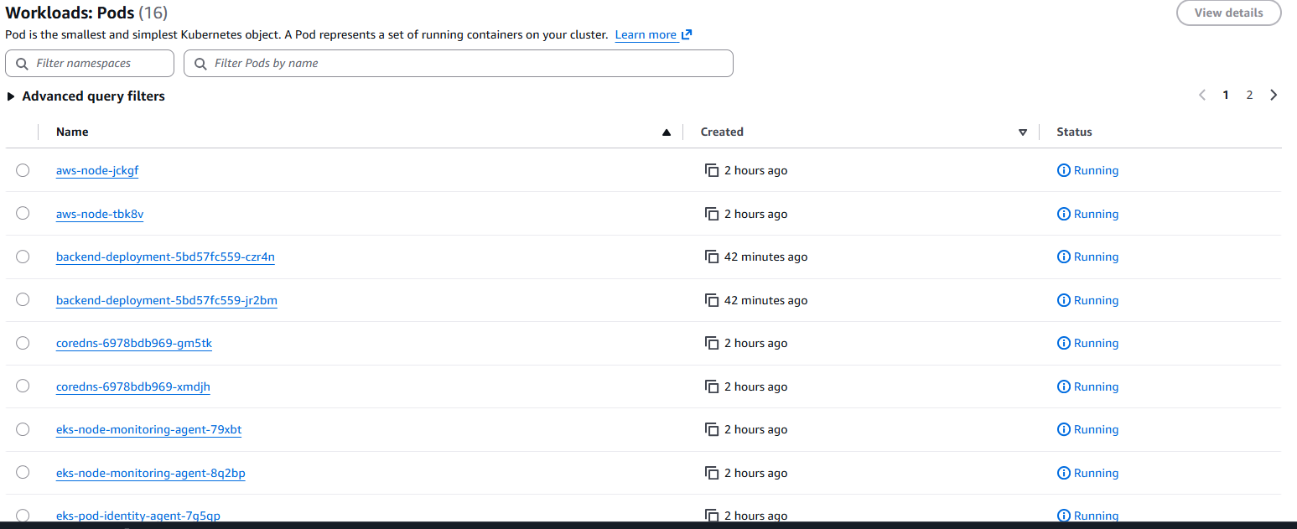
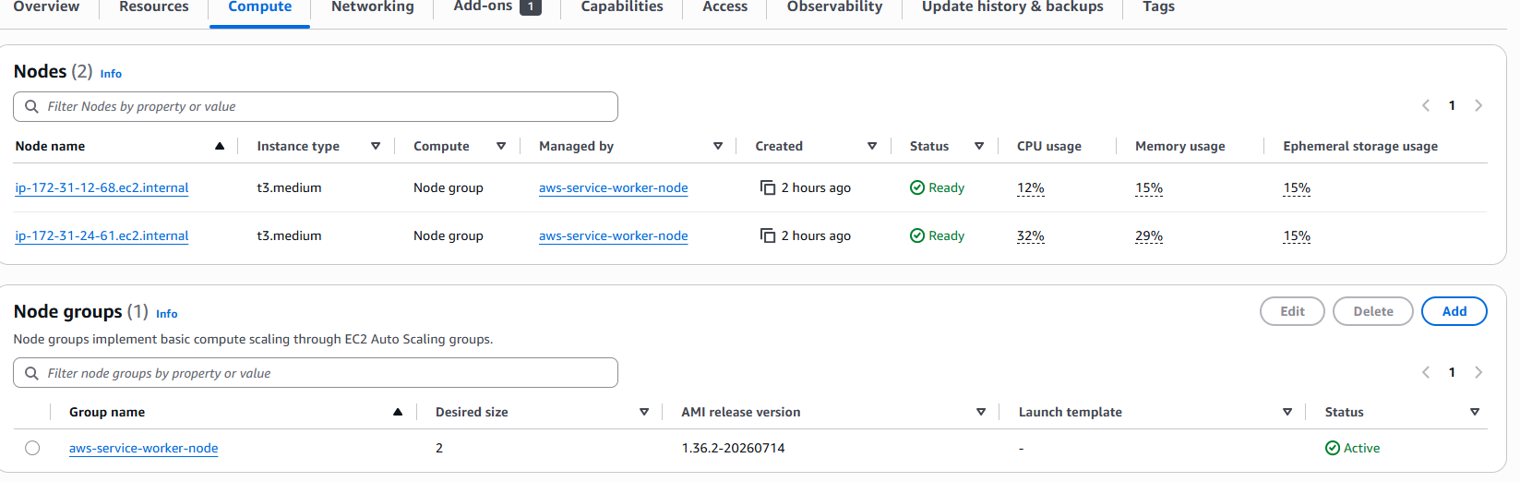
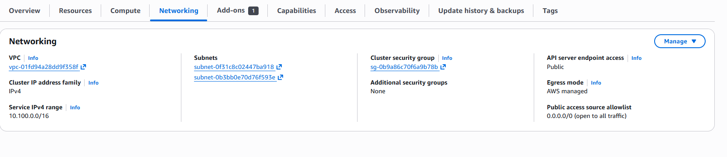
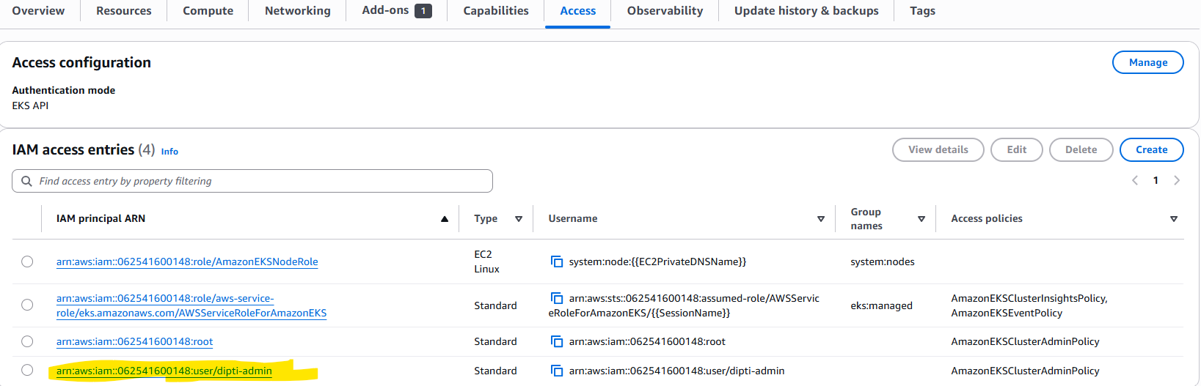
Figure 9: EKS Creating
9.2 This is control flow of EKS
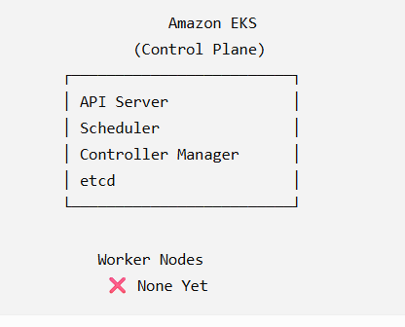

- Creating EKS Managed Worker Nodes (Servers/Chef of Restaurant)
10.1 Name : aws-service-worker-node, Role: select “create new”
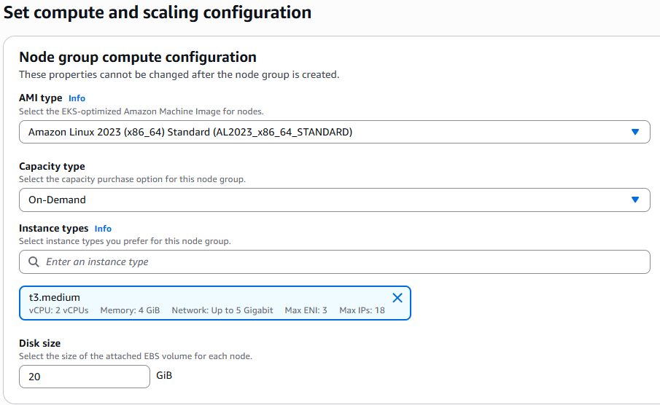
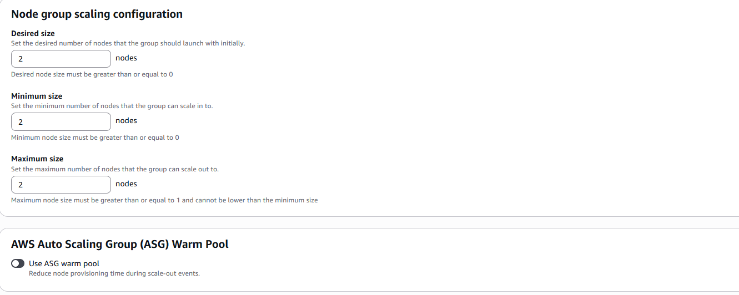
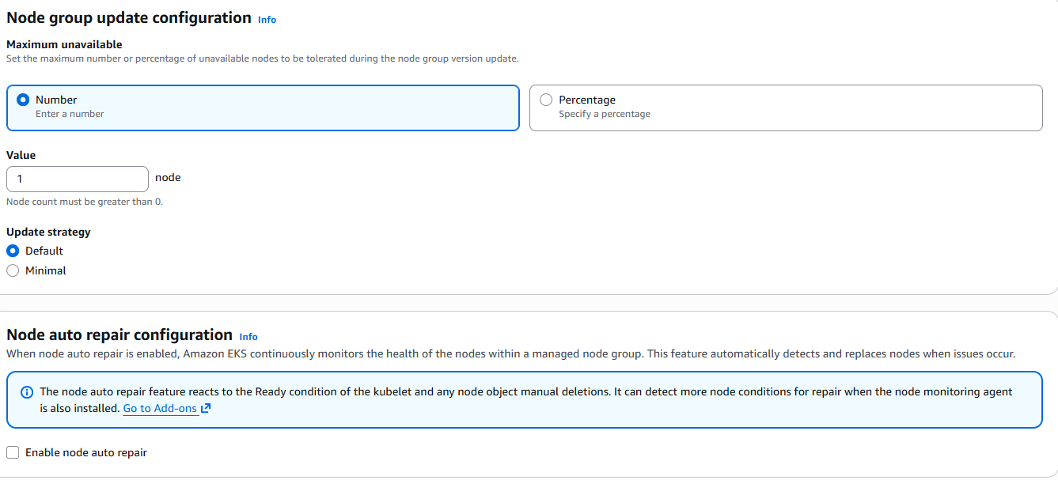
Figure 10: Managed-worker-nodes
10.2
Click “Create”. Once the Managed nodes are Active, appear in EKS.
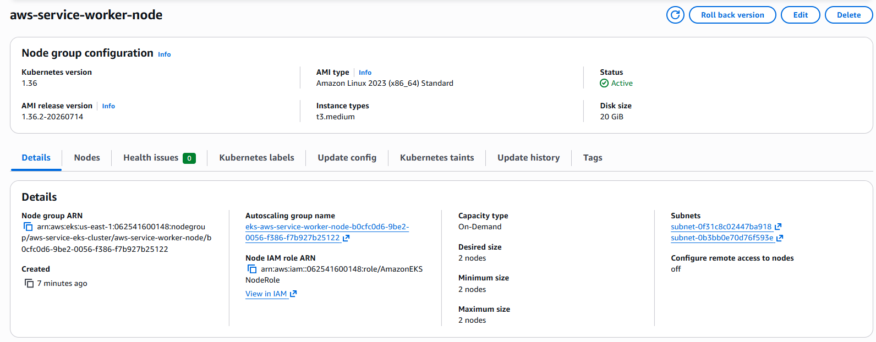
- Verify the Resource that gets created automatically
11.1 EC2 Worker nodes in EC2 console. Worker nodes were distributed across two Availability Zones, improving infrastructure availability. Application-level high availability also depends on running multiple Pod replicas and distributing them across those nodes.
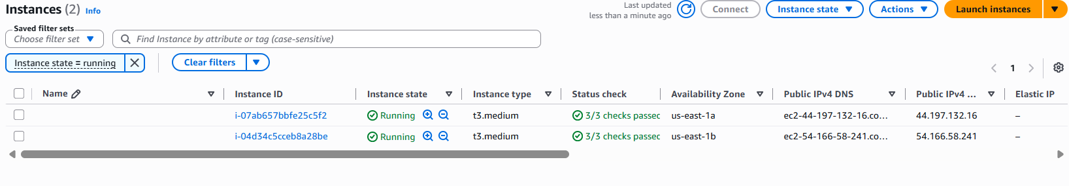
Figure 11: EC2 created
11.2 The EKS managed node group created an Auto Scaling Group to maintain and scale the EC2 worker-node capacity.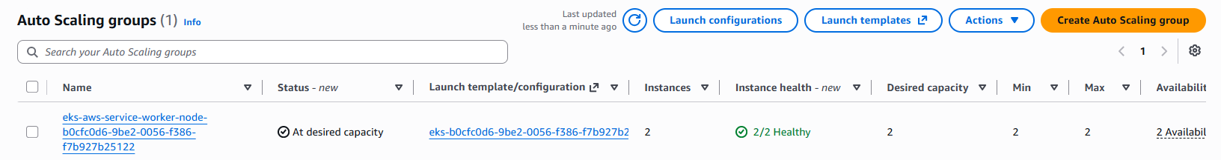
Figure 12 Auto Scaling group
11.3 This is control flow of services that automatically gets created
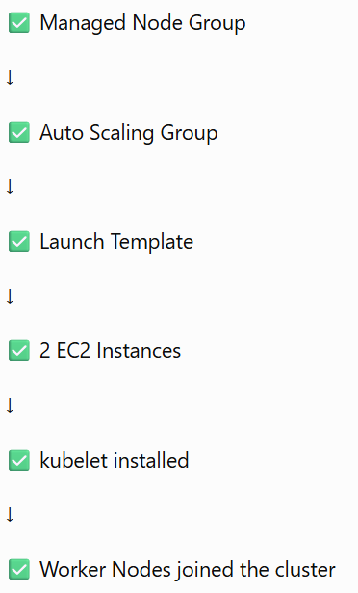
- Deploy the application
12.1 From local, connect to EKS Cluster. Make sure you are logged in to the AWS using your aws credentials.
aws eks update-kubeconfig --region us-east-1 --name aws-service-eks-cluster
12.2 Using AWS Console -> EKS-> EKS-Access – Give your IAM User access to get the information of the nodes on your local. IAM permission allowed your AWS CLI to retrieve cluster details. The EKS access entry grants permission inside Kubernetes to list nodes, deploy Pods and manage Services
12.3 Run the following to apply all the changes
kubectl apply -f backend-deployment.yaml
kubectl apply -f backend-service.yaml
kubectl apply -f frontend-deployment.yaml
kubectl apply -f frontend-service.yaml
kubectl get pods
kubectl get svc
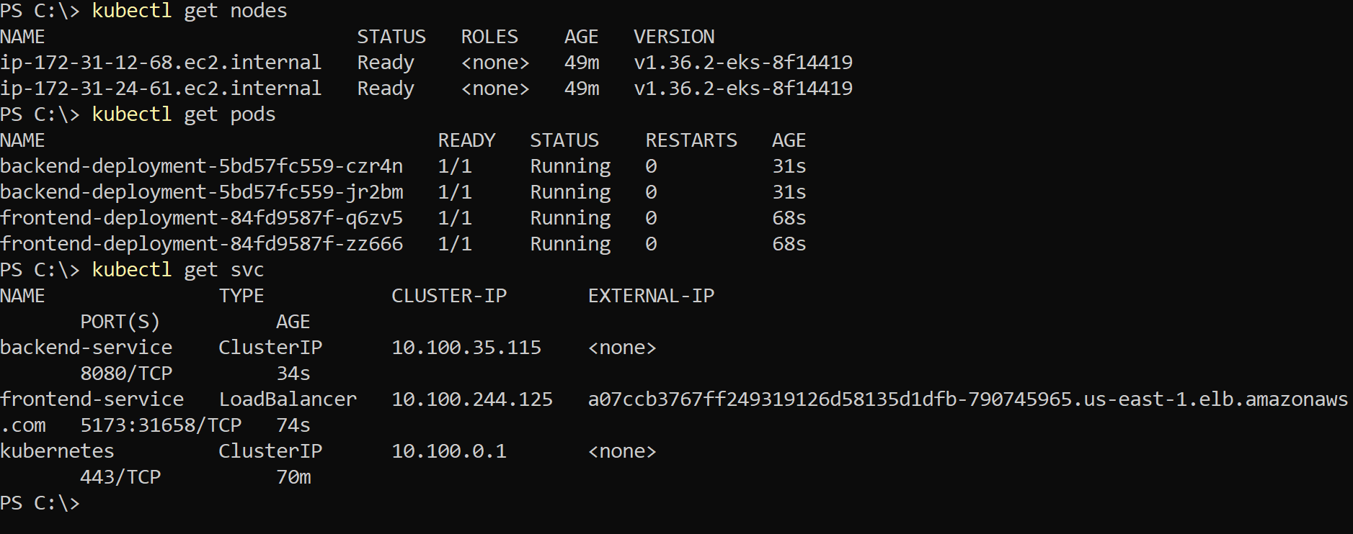
12.4 You can also verify Load Balancer has been created:
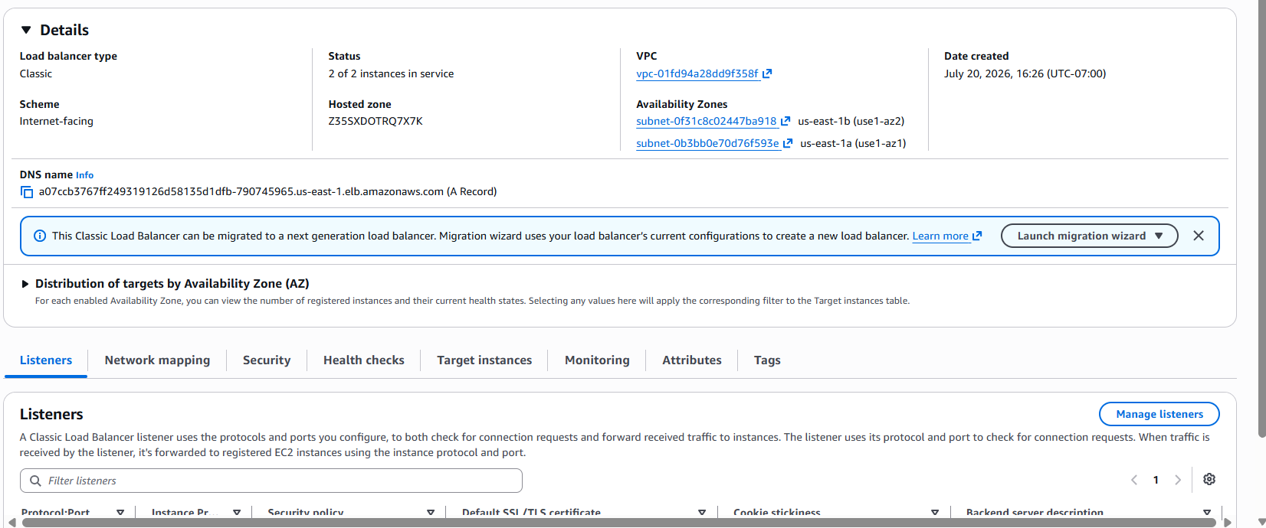
Figure 13 AWS Elastic Load Balancer provisioned by the Kubernetes LoadBalancer Service
- Test the application in Browser
13.1 Test the application using the DNS Name.
http://<DNS_NAME>:5173
http://a07ccb3767ff249319126d58135d1dfb-790745965.us-east-1.elb.amazonaws.com:5173/
13.2 You should see the webpage calling the backend services
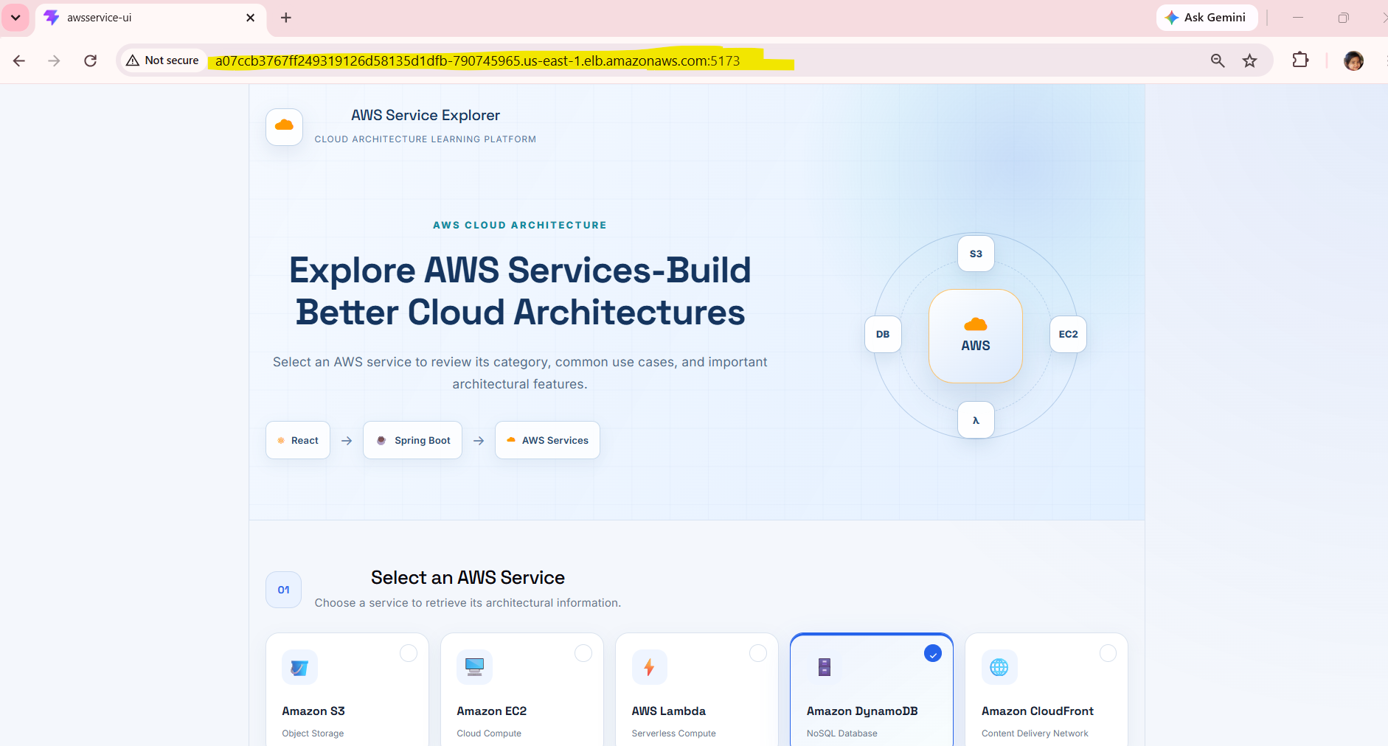
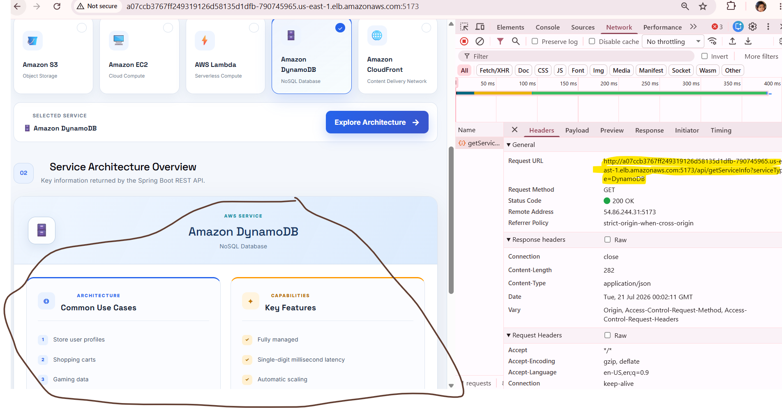
Figure 14 Containerize Cloud native Application
13.3 Control Flow:
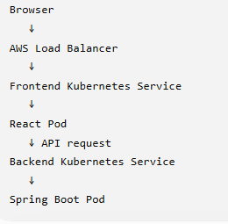

- Challenges & Resolutions:
Challenge | Resolution
Docker Desktop WSL issue | Enabled WSL Integration
React container not reachable | Updated Vite configuration
EC2 security group issue | Opened port 5173
Public IP changed after restart | Updated frontend API URL
Docker login to ECR failed | Configured IAM user and AWS CLI

- Delete the resources
15.1. Delete the Node Group first:
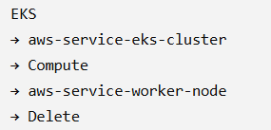
  - Delete the EKS Cluster
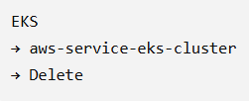
  - Verify the Load Balancer at:
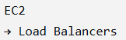
  - Check Elastic Network Interfaces
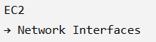

16. Key learning:
- Containerized React and Spring Boot applications using Docker.
- Built, tagged, and pushed application images to private Amazon ECR repositories.
- Created an Amazon EKS cluster and configured an EC2-backed managed node group.
- Defined Kubernetes Deployments and Services for the frontend and backend.
- Deployed multiple Pod replicas across EKS worker nodes.
- Exposed the frontend externally through a Kubernetes LoadBalancer Service.
- Kept the backend accessible internally through a ClusterIP Service.
- Verified Pod, Service, node, and Load Balancer health.
- Troubleshot container networking, ECR authentication, IAM access and frontend-to-backend connectivity.
- Deleted EKS, EC2, Load Balancer and networking resources to prevent unnecessary AWS charges.
- Conclusion
React → Docker → ECR → EKS → Managed Node Group → EC2 worker nodes → Kubernetes Deployments → Services → AWS Load Balancer → Spring Boot backend
This project successfully demonstrated end-to-end application development, orchestration, containerization, and cloud deployment on AWS. The solution was developed using Spring Boot for the backend and React for the frontend, containerized using EKS, stored in Amazon ECR, and deployed on an Amazon EKS cluster using a managed node group backed by Amazon EC2 worker nodes.

