Terraform
Terraform is an Infrastructure as Code (IaC) tool used to provision and manage cloud infrastructure through configuration files. Instead of manually creating AWS resources from the AWS Console, we define the required infrastructure in code, such as EC2 instances, VPCs, Security Groups, Load Balancers, Auto Scaling Groups, and EKS clusters. Terraform then automatically creates and manages those resources in a consistent and repeatable manner.
Organizations prefer Terraform because the same configuration files can be used across Development, QA, UAT, and Production environments, ensuring consistency, reducing manual errors, enabling version control, and making infrastructure easy to reproduce and maintain. Since the infrastructure is stored as code, it can be version-controlled in Git, reviewed through pull requests, and integrated into CI/CD pipelines. The same tested Terraform configuration can be promoted from Development to QA, UAT, and Production, ensuring every environment is built consistently
Terraform and AWS CloudFormation are both Infrastructure as Code tools used to provision cloud infrastructure. The main difference is that CloudFormation is an AWS-native service and works only with AWS resources, whereas Terraform is cloud-agnostic and can provision infrastructure across multiple cloud providers such as AWS, Azure, Google Cloud, Kubernetes, and many other platforms using providers.
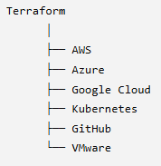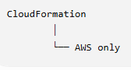

Terraform | CloudFormation
Open source (from HashiCorp) | AWS-managed service
Multi-cloud | AWS only
Uses HCL (HashiCorp Configuration Language) | Uses YAML or JSON
State stored in terraform.tfstate | State managed as CloudFormation stacks
Can manage AWS and many non-AWS services | Manages AWS resources

Here's a simple analogy
Imagine Terraform is a construction manager.
Before it can build a house, it must know:
- Which country it's building in → AWS Provider
- Which city → AWS Region
- Which property → VPC/Subnet
- What to build → EC2, ALB, EKS, etc.
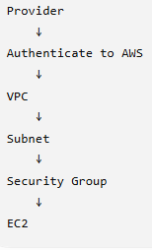

Installation On windows:
winget install HashiCorp.Terraform

Everything in Terraform is a Block
Terraform configuration is made up of blocks.
- terraform { }
- provider { }
- resource { }
- output { }

Important Commands
- terraform init
- terraform plan
- terraform apply
- terraform destroy

3 principles of Terraform
- References create dependencies
- Terraform builds a dependency graph
- Independent resources can be created in parallel

Code:
- Create a folder in VS Code: terraform-ec2-demo
- Create a file: main.tf (Terraform only reads files ending in .tf)
- In main.tf :
terraform {
required_providers {
aws = {
source = "hashicorp/aws"
version = "~> 6.0"
}
}
}

provider "aws" {
region = "us-east-1"
}

resource "aws_instance" "web_server" {

ami = "ami-084568db4383264d4"
instance_type = "t3.micro"

tags = {
Name = "Terraform-EC2"
Environment = "Learning"
Project = "Terraform"
}
}}

- Configure your AWS credentials on this laptop using the AWS CLI?

//login to your AWS Cli – If new user:
aws configure – Enter the access key, secret key and region
//Verify if the acct is set
aws sts get-caller-identity
aws configure list

- Terminal: terraform init
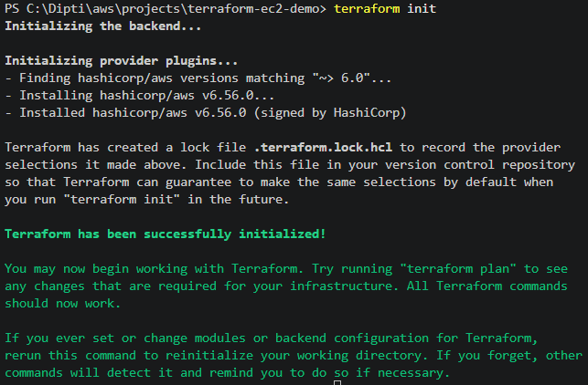

- Once init runs, Look inside your folder. You should now see something like:
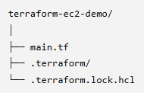
- main.tf : Defines your infrastructure
- .terraform folder: Inside it are the downloaded provider plugins
- .terraform.lock.hcl: The lock file ensures everyone on the team uses the same provider version.
- Before we run terminal -> terraform plan, make sure to run aws sts get-caller-identity & check if your aws acct is set.
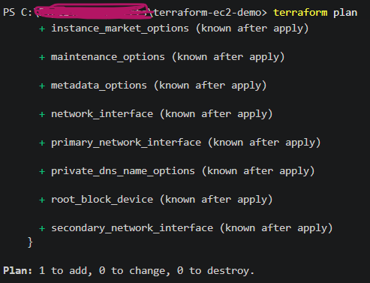
This means:
✅ Create 1 resource
❌ Modify nothing
❌ Delete nothing

- This is my AWS console- EC2. No instances running.
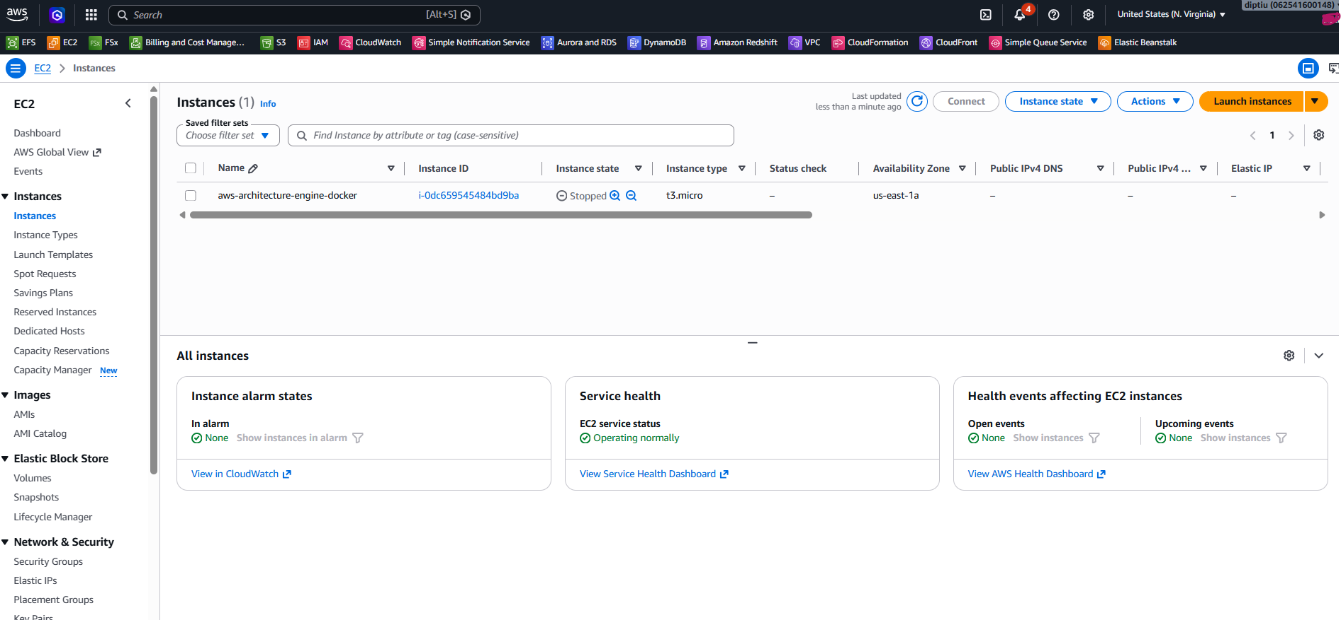
- Now, terminal -> terraform apply. This will create an EC2 Instance.
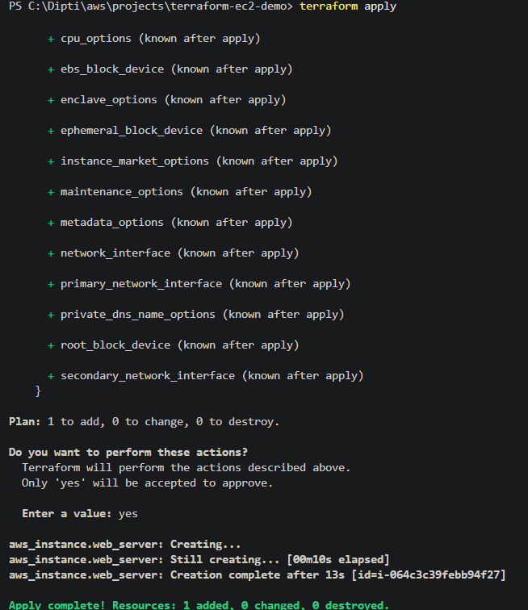
- New EC2 instance in Console is created:
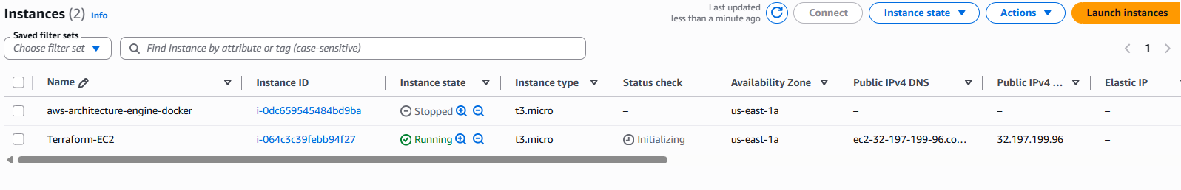
- Terraform also creates terraform.tfstate
What is the Terraform State File?
The Terraform state file (terraform.tfstate) stores Terraform's current view of the infrastructure it manages. It maps the resources defined in the Terraform configuration to the actual resources in the cloud, including their IDs and attributes. Terraform uses this state to determine what needs to be created, updated, or destroyed during future operations.
What happens if someone manually deletes a Terraform-managed resource from AWS?
When terraform plan runs, Terraform compares the desired configuration, the state file, and the actual infrastructure in AWS. It detects that the resource is missing and plans to recreate it so that the actual infrastructure matches the desired state.
What is Configuration Drift?
Configuration drift occurs when the actual infrastructure differs from the desired infrastructure defined in Terraform because changes were made manually or outside of Terraform. During terraform plan, Terraform detects the drift and proposes changes to reconcile the actual infrastructure with the desired configuration.
- Run terminal - terraform destroy
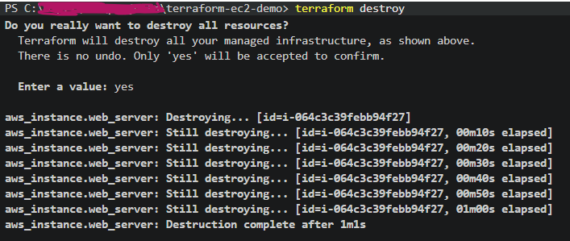
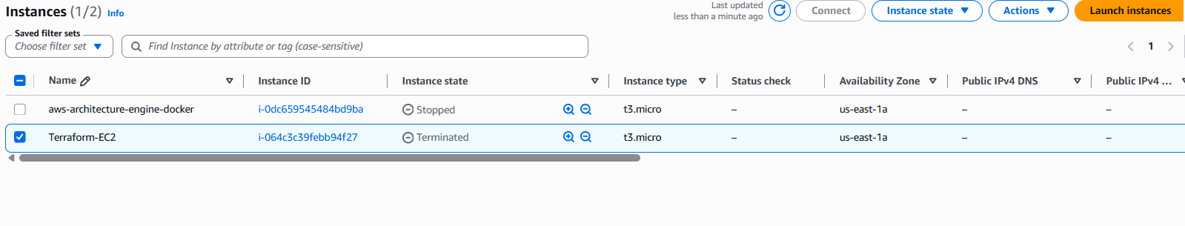
- We provisioned an EC2 instance using Terraform, verified the execution with terraform plan, deployed it with terraform apply, and then cleaned up the infrastructure using terraform destroy.

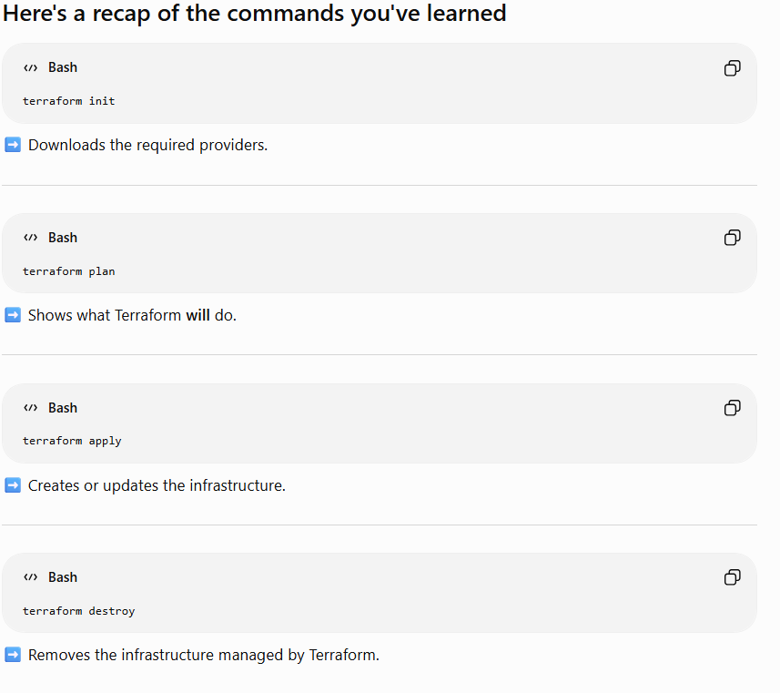

Day2 : End-to-End Architecture

Terraform → VPC → Public Subnet → Internet Gateway → Route Table → Security Group → EC2
We’ll also use:
- variables.tf for configurable values
- outputs.tf to display the EC2 public IP
- terraform.tfvars for your selected values
- Terraform state to track the infrastructure

Think of Terraform as a construction manager:
- main.tf = construction instructions
- variables.tf = customizable choices
- terraform.tfvars = actual choices you selected
- outputs.tf = completed building information
- terraform.tfstate = Terraform’s record of what it constructed

  - Created the tf file for each aws service and than applied it.
  - Used the output.tf to print the values/id of the resources created.
  - Now we’ll refactor the hard-coded values into variables. This teaches how the same Terraform configuration can be reused for development, testing, or production.
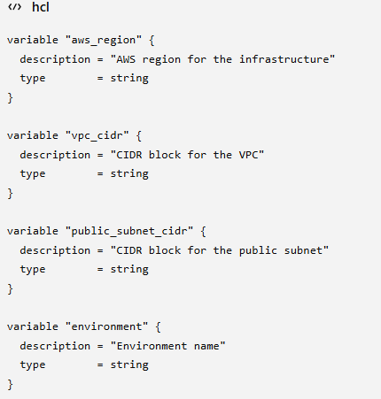

Things we learn

✅ Provider: This tells Terraform which cloud provider to talk to.
✅ Variables: What values are required.
✅ terraform.tfvars: Variables define what values are required, while terraform.tfvars provides the actual values. This allows us to deploy the same Terraform code across multiple environments like dev, QA, and production without modifying the code.

✅ Outputs: Values that needs to be printed

✅ State: Terraform now knows exactly what it created

✅ forces replacement: • Destroy the existing VPC. • Create a new VPC with the new CIDR.

✅ Modules: how to package and reuse infrastructure

✅ Remote State: storing state securely in S3 with locking

✅ Workspaces: separate dev/test/prod state

✅ count and for each: creating multiple resources dynamically

✅ Drift detection and terraform import

✅ terraform destroy: cleanly removing infrastructure

✅ terraform plan: performs a dry run. It compares the Terraform configuration, the Terraform state file, and the actual infrastructure in AWS, then shows exactly what changes would be made without making any modifications. This allows us to review additions, updates, replacements, or deletions before execution

✅ terraform apply: takes that approved execution plan and performs the changes to create, update, or destroy infrastructure

Modules:
Terraform Modules allow us to package reusable infrastructure into standardized building blocks. Instead of duplicating Terraform code across projects, we define resources once and reuse them across development, QA, and production. This improves maintainability, reduces duplication, enforces standards, and simplifies future changes

how does the root module communicate with the network module? The root module passes input variables to the child module using the module block. The child module declares those variables in its own variables.tf file and uses them to create resources. The child module then exposes values through outputs, which the root module can reference using module.<module_name>.<output_name>.

For different env: The project structure would be:
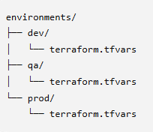

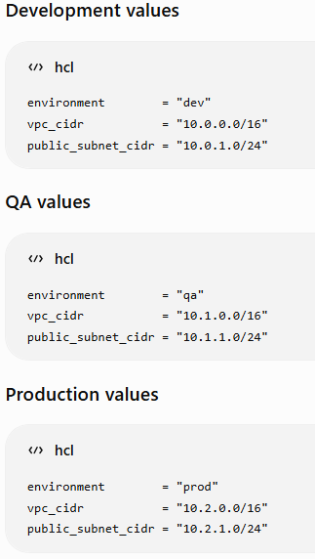

One reusable network module, with different values for each environment.

deploy a particular environment using:
terraform plan -var-file="environments/dev/terraform.tfvars"
terraform apply -var-file="environments/dev/terraform.tfvars"

Different environments should not share the same Terraform state. Each environment needs isolated state so that applying changes to development cannot accidentally modify production.
We would use one standardized network module and pass different input values for development, QA, and production. We would also maintain separate state for each environment to ensure isolation and prevent changes in one environment from affecting another

Topic: Remote State & State Locking
Remote state provides a single shared source of truth for the infrastructure. It enables collaboration across engineering teams, ensures everyone works with the same state, and prevents inconsistencies that occur when state files are stored locally
State locking ensures that only one Terraform operation can modify the state file at a time. It prevents concurrent updates that could corrupt the Terraform state or leave the infrastructure in an inconsistent state.

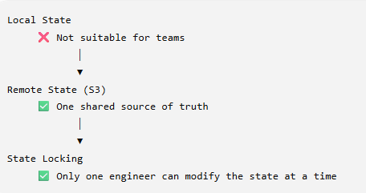

Why don't we store terraform.tfstate in GitHub?
Terraform state files often contain sensitive infrastructure metadata and, in some cases, secrets, so they should not be stored in a source code repository. Additionally, GitHub does not provide Terraform state locking, which means multiple engineers could overwrite each other's state changes. Instead, we store the state in a remote backend such as Amazon S3 and use state locking so the entire team works safely from a single source of truth.

Workspace:
A workspace allows the same Terraform configuration to maintain different state files.

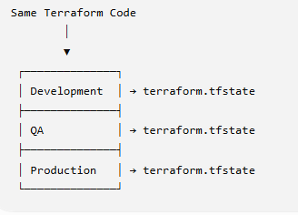
The code is identical. The state is different.
Terraform Workspaces allow the same Terraform configuration to manage multiple independent environments by maintaining separate state files for each workspace. This lets us reuse the same Infrastructure as Code while isolating the state of development, QA, and production
Terraform Workspaces are useful for managing multiple similar environments with the same Terraform configuration, especially for development, testing, or personal projects. In larger enterprise environments, production is often managed using separate directories, repositories, or backend configurations to provide stronger isolation, independent access controls, and separate deployment pipelines

//Create Workspace
terraform workspace new dev
terraform workspace new qa
terraform workspace new prod

//List the workspaces
terraform workspace list

//Switch workspaces:
terraform workspace select dev

Each workspace gets its own Terraform state. The same code, but Different infrastructure.
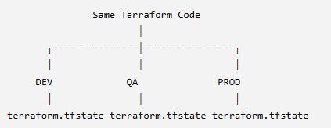

Why are Workspaces useful?
Terraform Workspaces allow the same Terraform configuration to manage multiple independent environments by maintaining separate state files for each workspace. This lets us reuse the same Infrastructure as Code while isolating the state of development, QA, and production

count vs for_each
count is similar to a for loop because it repeats the creation of a resource multiple times.

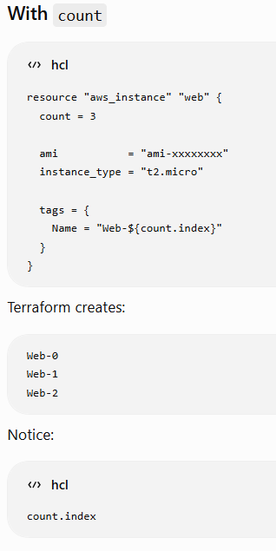
Enter for_each
Suppose instead of three anonymous servers, you have three named applications:
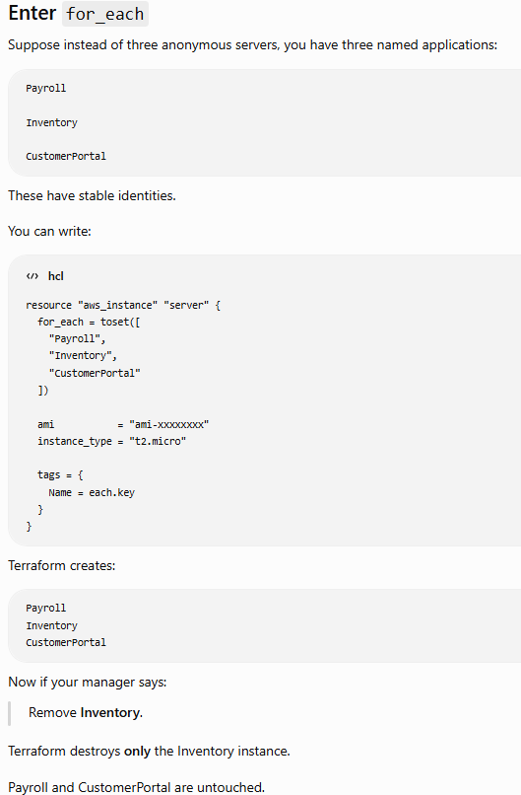
for_each is much safer for collections of uniquely identifiable resources.

When would you use count and when would you use for_each?
count is appropriate when creating multiple identical resources where only the quantity matters, such as creating three identical EC2 instances. for_each is preferred when each resource has a unique identity or configuration, such as applications, IAM users, or S3 buckets, because resources are tracked by key rather than by numeric index, making future additions and removals much safer

Drift
Terraform configuration ≠ Actual Infrastructure
What is Infrastructure Drift?
Infrastructure Drift occurs when the actual cloud infrastructure is changed outside Terraform, causing it to differ from the Terraform configuration and state. Terraform detects this difference during terraform plan and proposes changes to bring the infrastructure back to the desired state.
What does terraform import do?
terraform import brings an existing cloud resource under Terraform management by associating it with a Terraform resource in the state file. It does not create or modify the resource; it only updates Terraform's state so the resource can be managed going forward. It only updates the state. You still need to write the corresponding Terraform configuration so that future plan and apply operations work correctly.

What is tfstate and tfvar files?
terraform.tfstate should generally not be committed because it contains Terraform's current infrastructure state, changes frequently, and may include sensitive information such as resource IDs, IP addresses, or endpoints. In team environments, it's typically stored remotely in an S3 backend with DynamoDB for state locking.
terraform.tfvars is also usually excluded because it often contains environment-specific values and secrets like database passwords or API keys. Instead, teams commit a terraform.tfvars.example template and keep the actual terraform.tfvars local or provide values through CI/CD pipelines or secret managers.

Here's everything we've learned:
Fundamentals
- ✅ Providers
- ✅ Resources
- ✅ Variables
- ✅ terraform.tfvars
- ✅ Outputs
- ✅ Dependency Graph
- ✅ State (terraform.tfstate)
Resource Lifecycle
- ✅ terraform init
- ✅ terraform validate
- ✅ terraform fmt
- ✅ terraform plan
- ✅ terraform apply
- ✅ terraform destroy
Enterprise Terraform
- ✅ Modules
- ✅ Remote State
- ✅ State Locking
- ✅ Workspaces
- ✅ count
- ✅ for each
- ✅ Drift Detection
- ✅ terraform import

Explain Terraform Workflow:
In an enterprise project, I first organize the Terraform code into reusable modules, such as a network module containing VPC, subnets, route tables, internet gateways, and security groups. At the root level, I keep the provider configuration, variables, outputs, and the module definitions. Variables are declared in variables.tf, while environment-specific values are provided through terraform.tfvars.
Next, I run terraform init to initialize the working directory and download the required providers and modules. I then use terraform fmt to format the code and terraform validate to check that the configuration is syntactically valid.
Before making any changes, I run terraform plan. Terraform compares the desired configuration, the current Terraform state, and the actual AWS infrastructure to generate an execution plan. After reviewing the plan, I run terraform apply to provision or update the infrastructure, and Terraform updates the state file to reflect the changes.
In a team environment, I store the Terraform state remotely in an Amazon S3 backend so everyone shares a single source of truth. I also enable state locking to prevent multiple engineers from modifying the state simultaneously.
To improve reusability, I use modules and variables. For multiple identical resources, I use count, and for uniquely identifiable resources, I use for_each. If an organization already has existing AWS infrastructure, I can use terraform import to bring those resources under Terraform management. Finally, I use separate workspaces or, in larger enterprises, separate environments with independent state and deployment pipelines to isolate development, QA, and production.

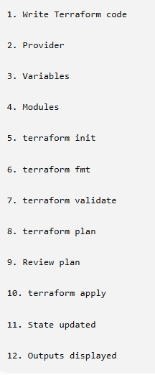

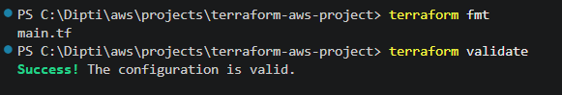
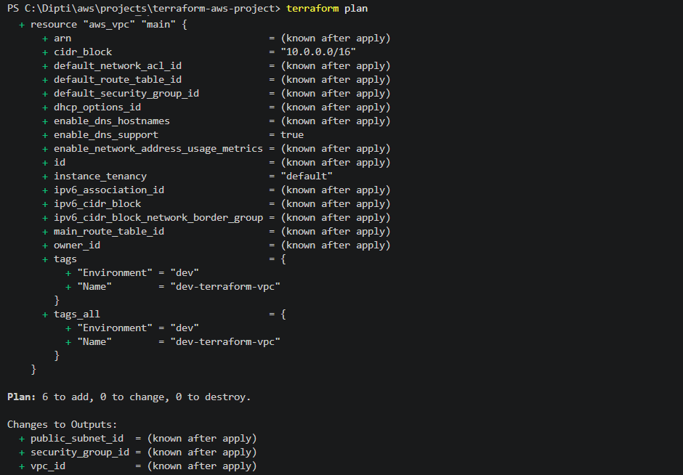

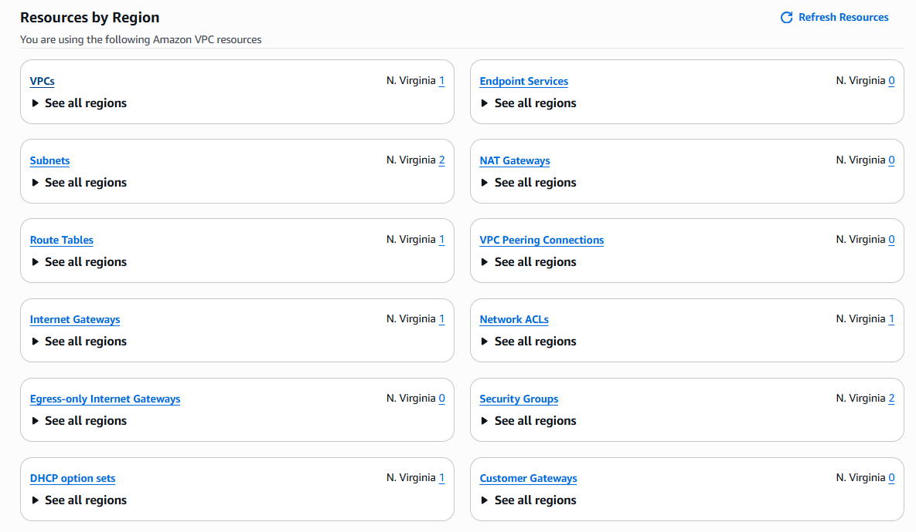
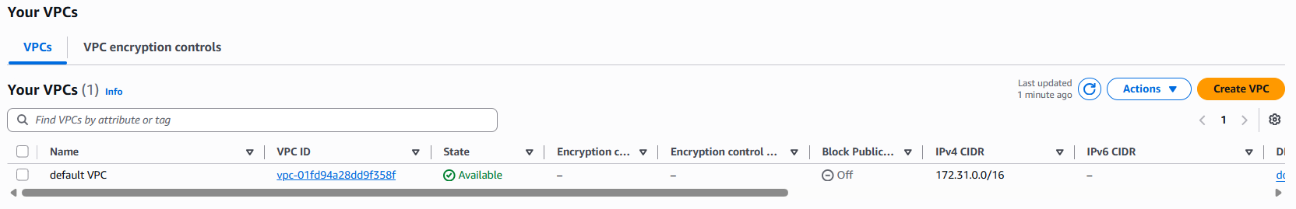

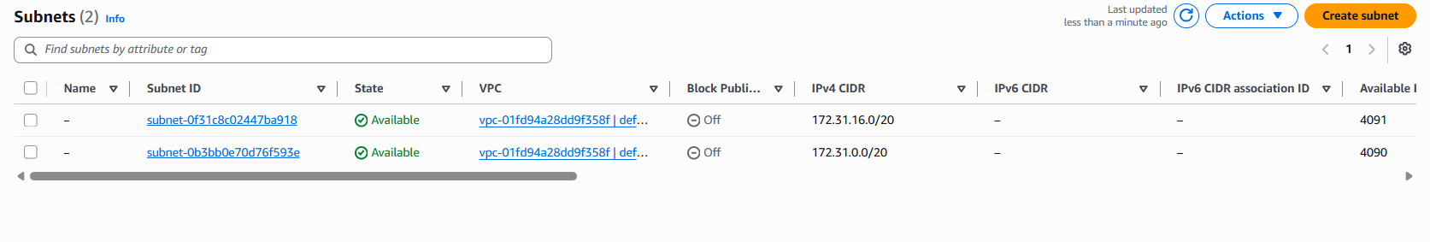
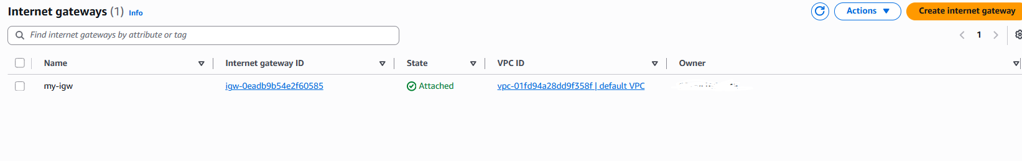
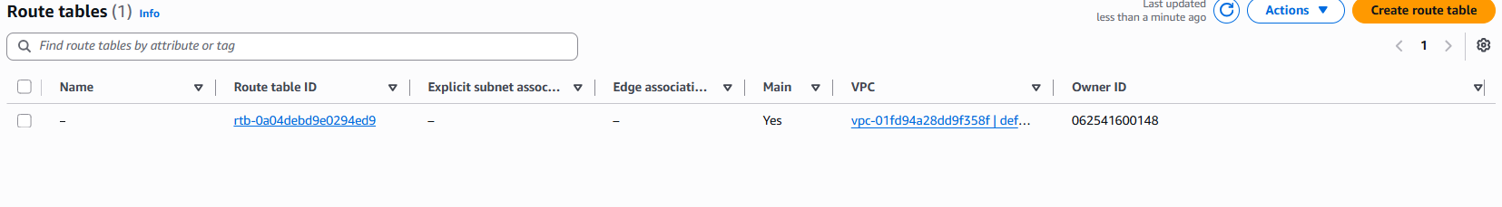
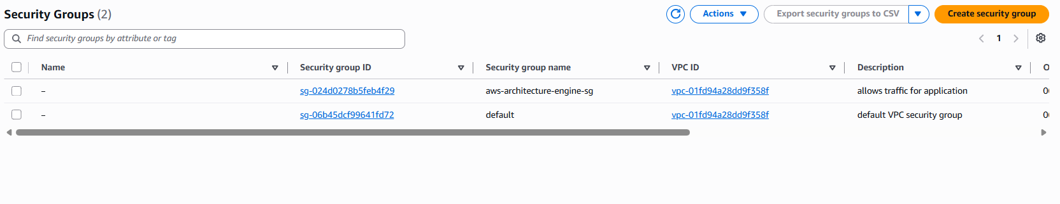

After terraform is applied, infrastructure gets created
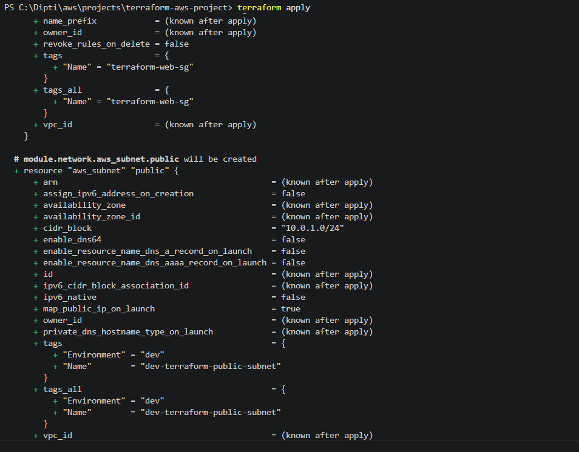
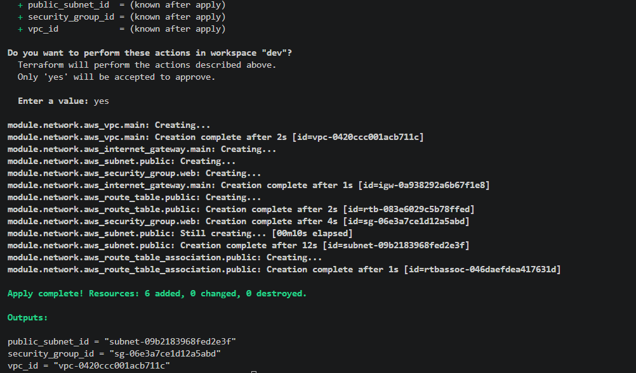
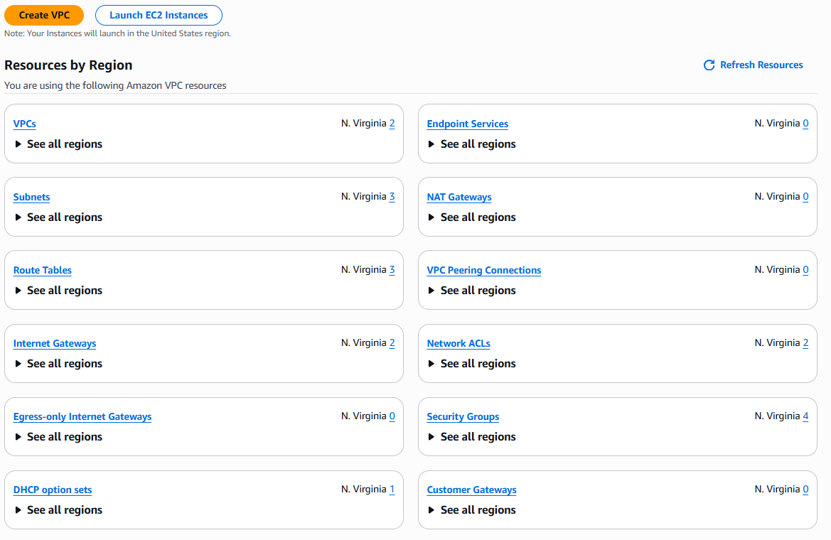

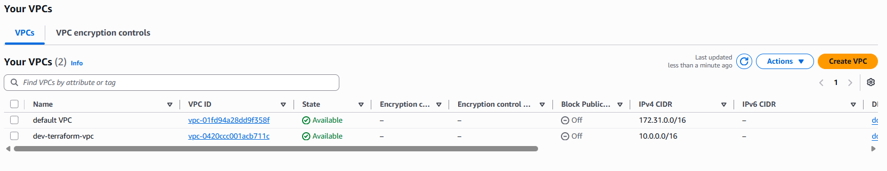
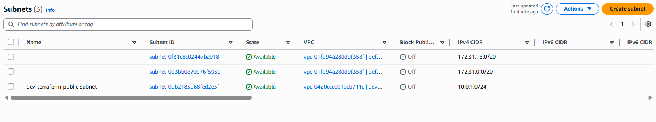
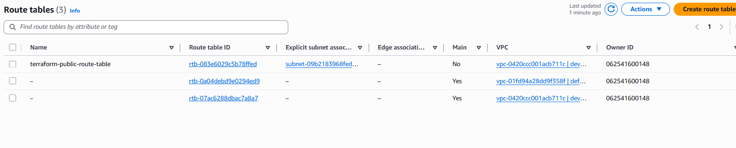
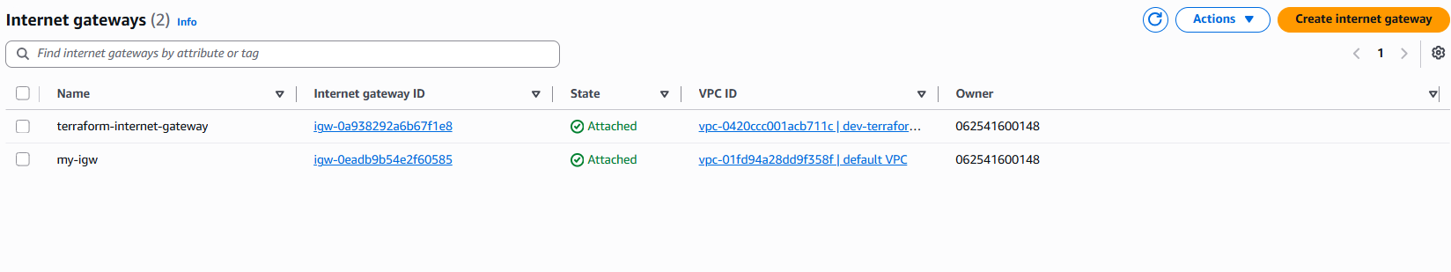
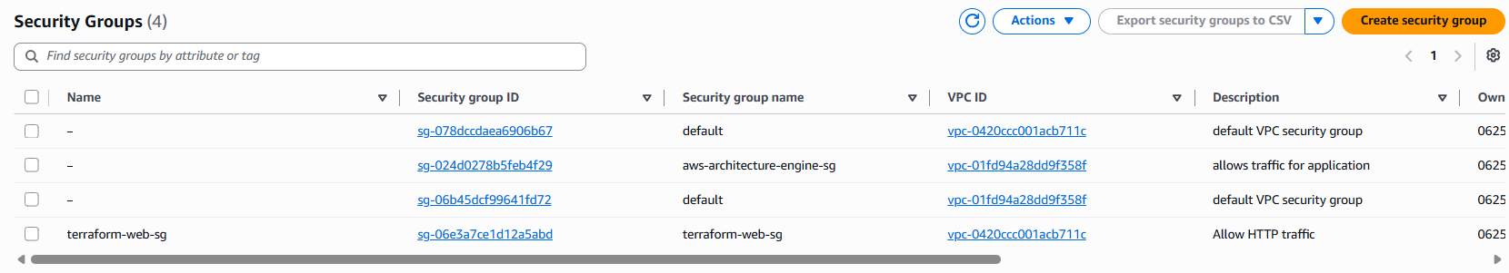

After terraform destroy:

